1. **Merge Two Sorted Lists**

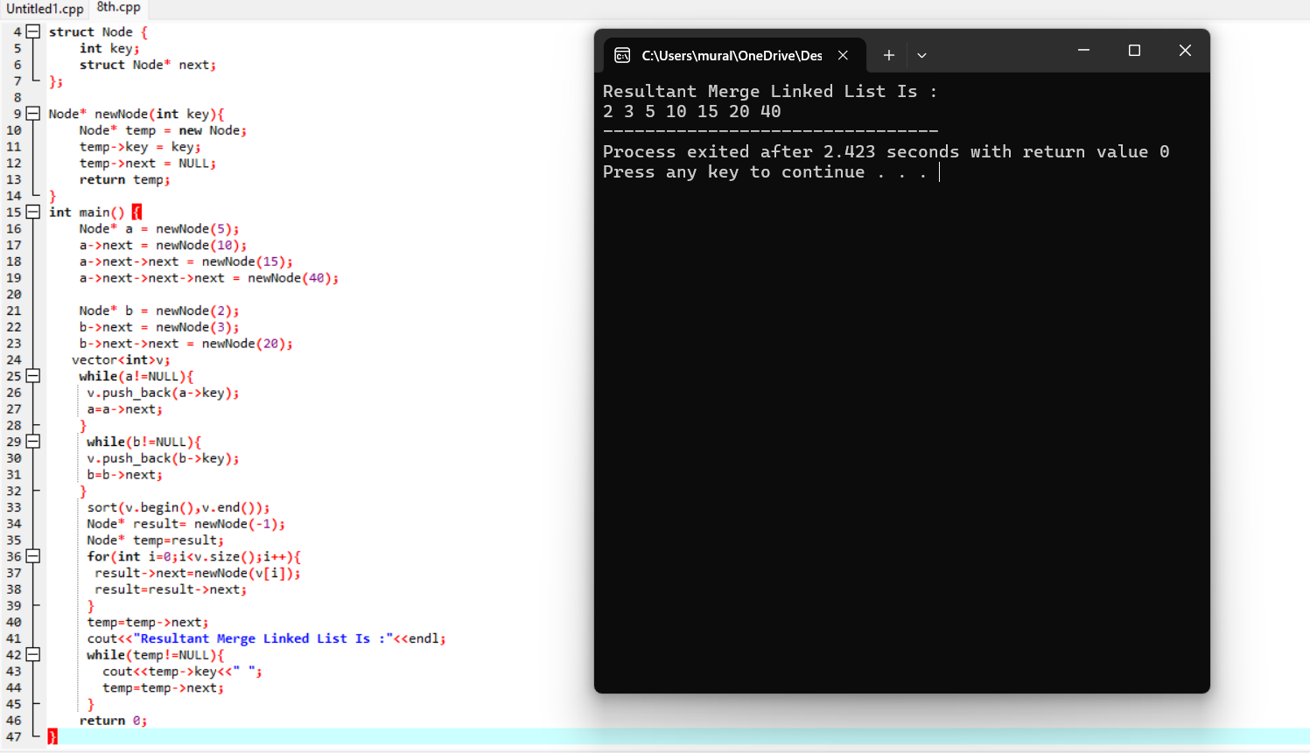

1. **Merge k Sorted Lists**

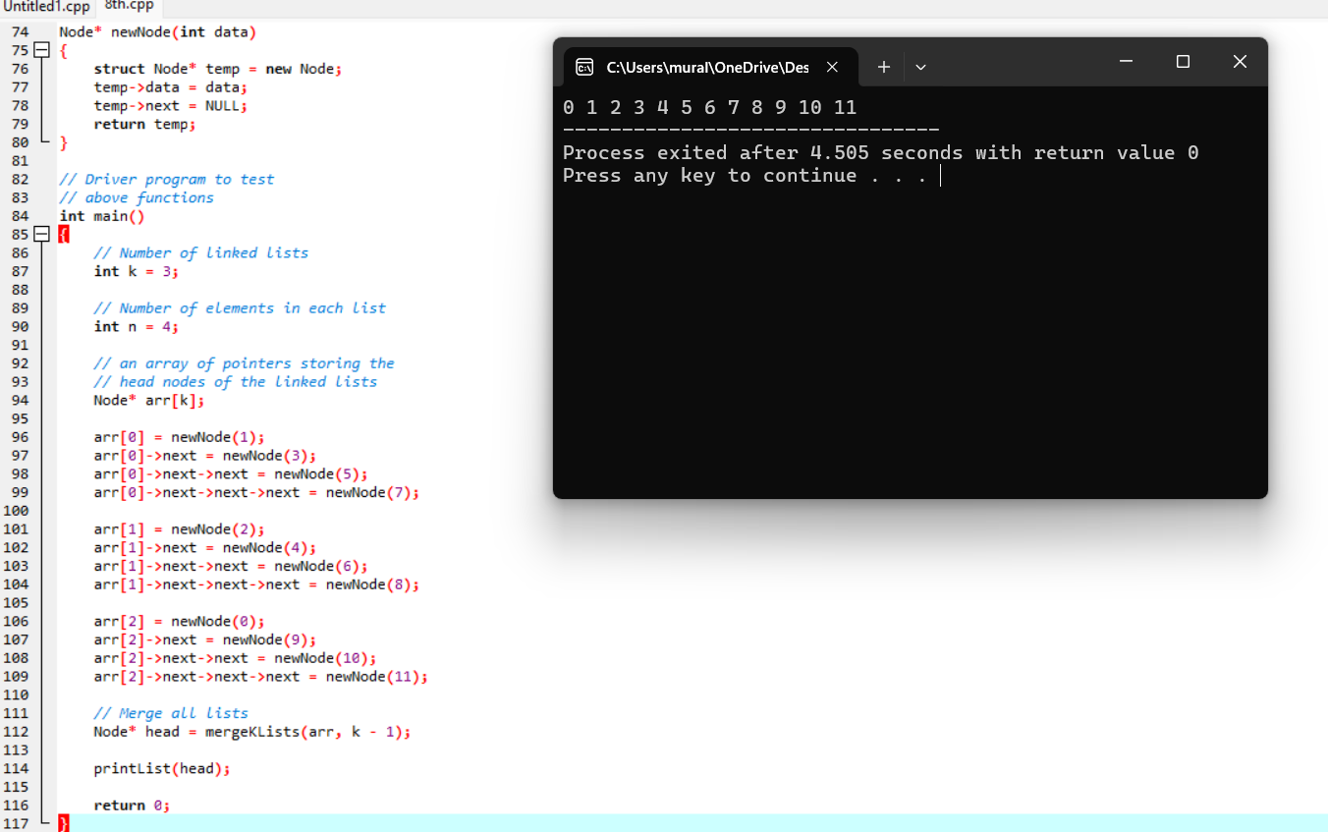

1. **Remove Duplicates from Sorted Array**

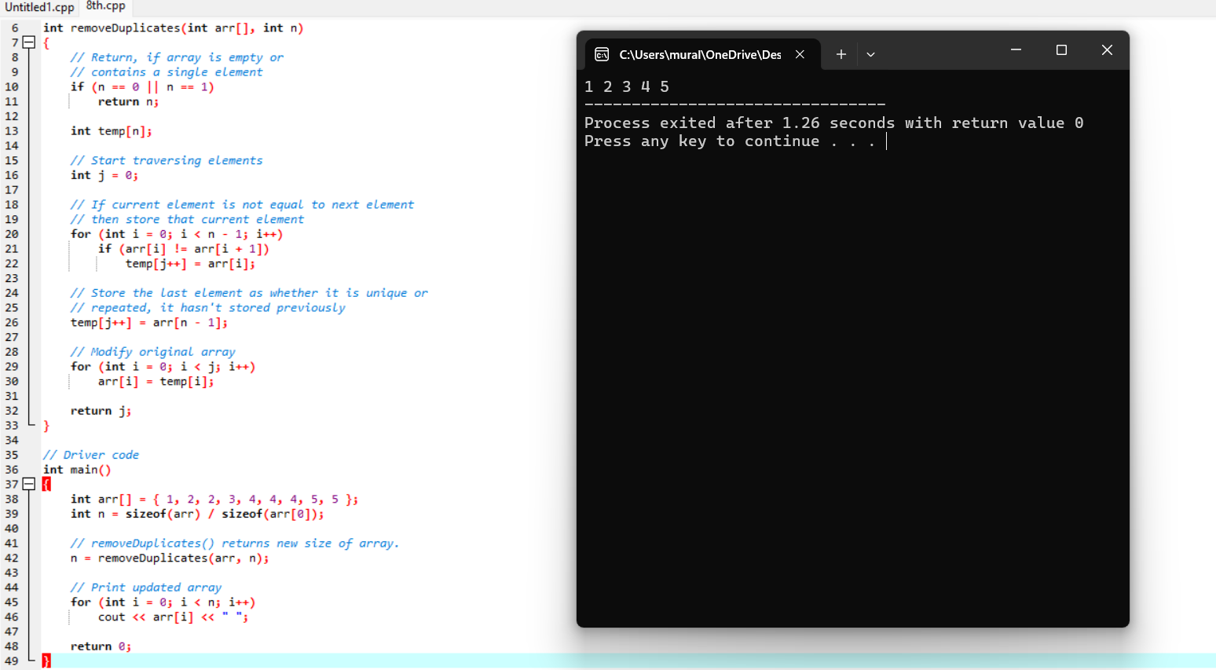

1. **Search in Rotated Sorted Array**

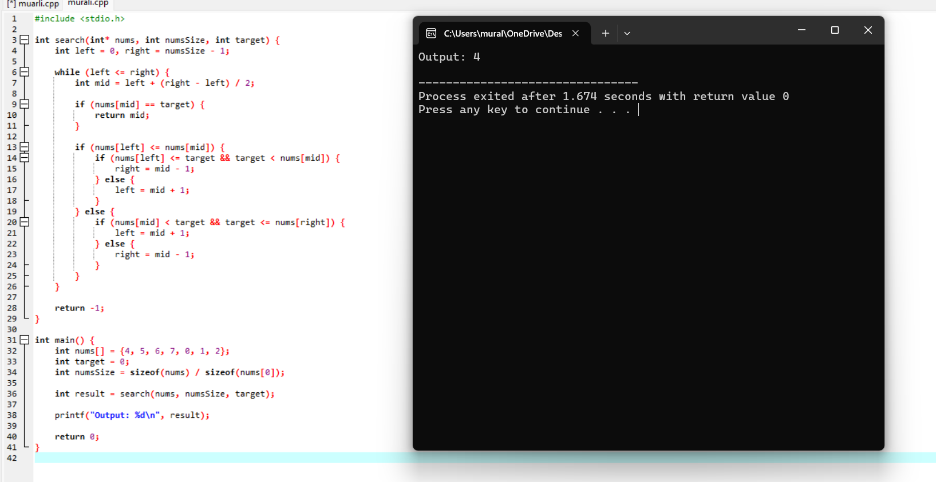

1. **Find First and Last Position of Element in Sorted Array**

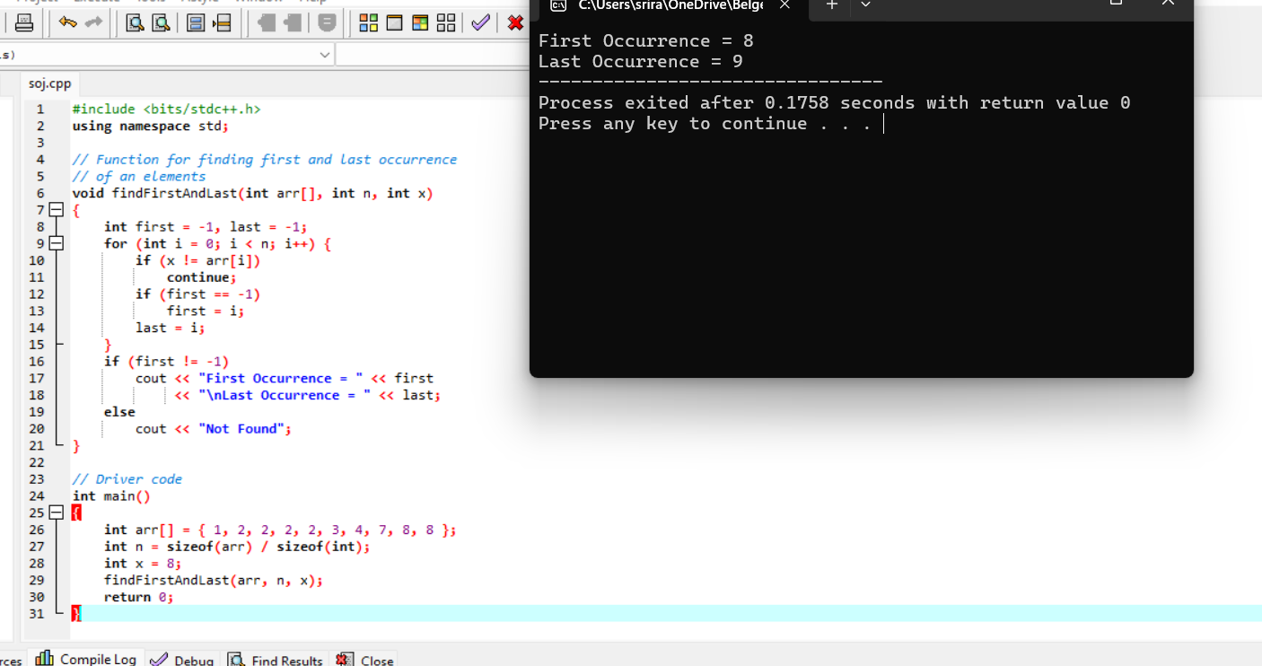

1. **Sort Colors**

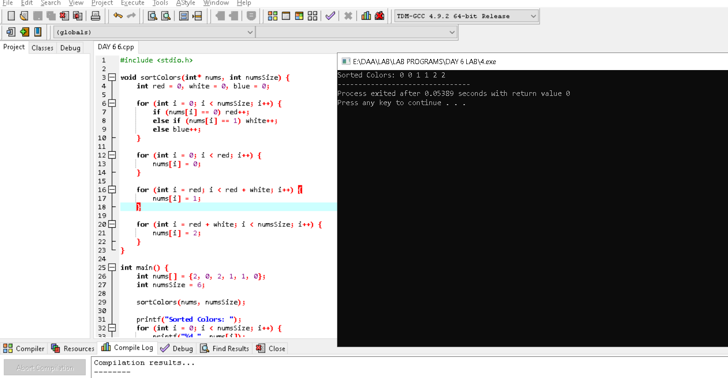

1. **Remove Duplicates from Sorted List**

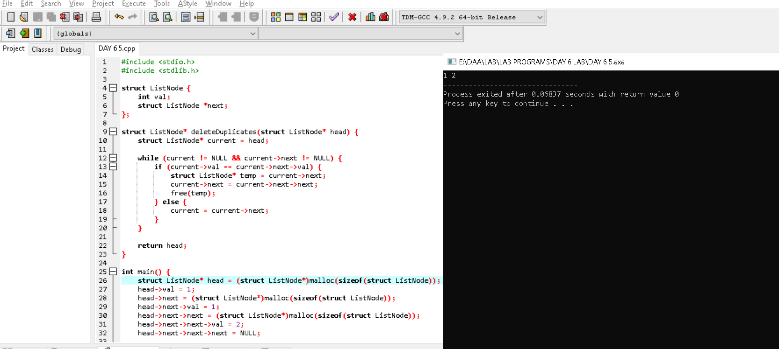

1. **Merge Sorted Array**

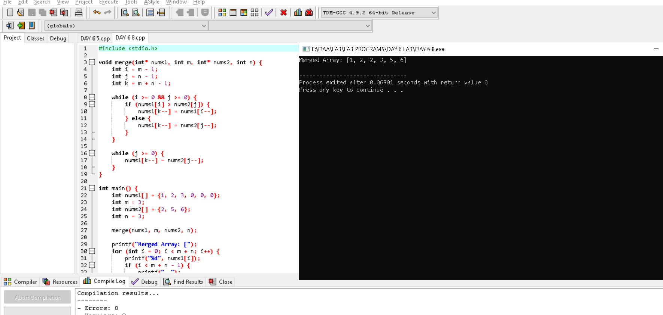

1. **Convert Sorted Array to Binary Search Tree**

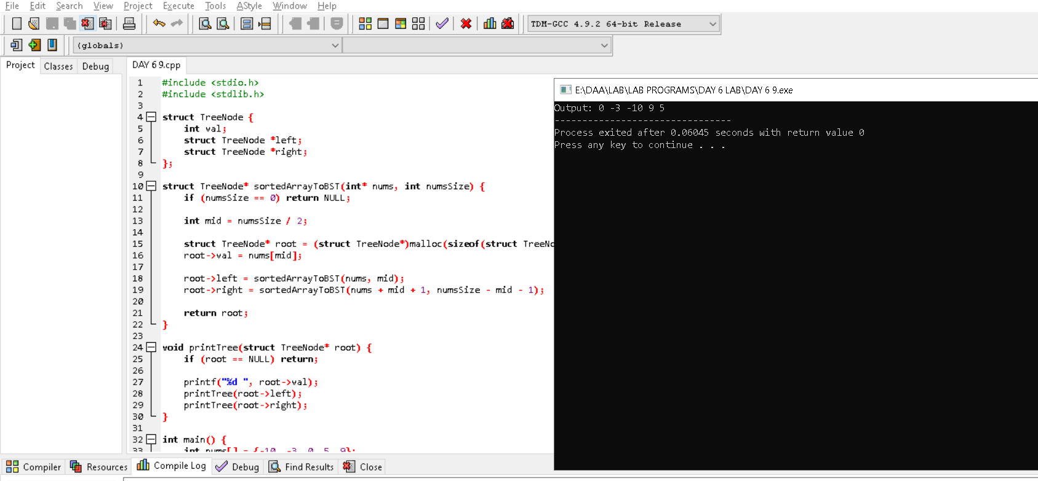

1. **Convert Sorted Array to Binary Search Tree**

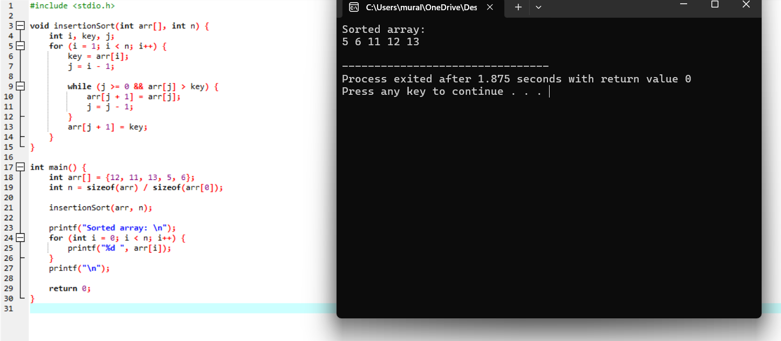

1. **Sort Characters By Frequency**

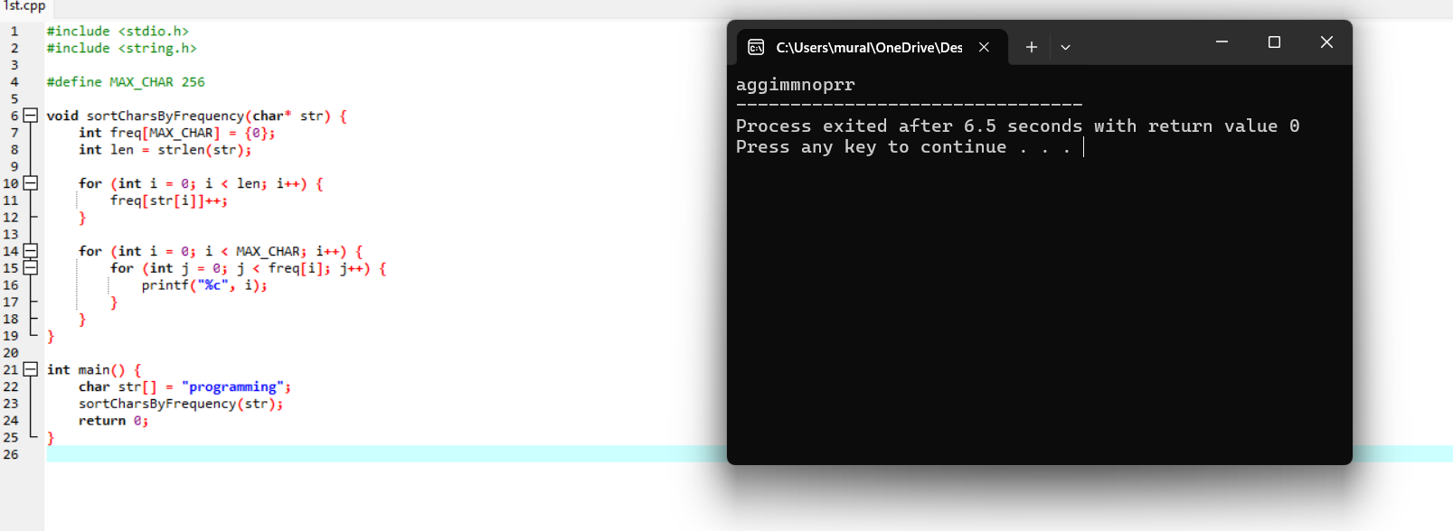

1. **Max Chunks To Make Sorted**

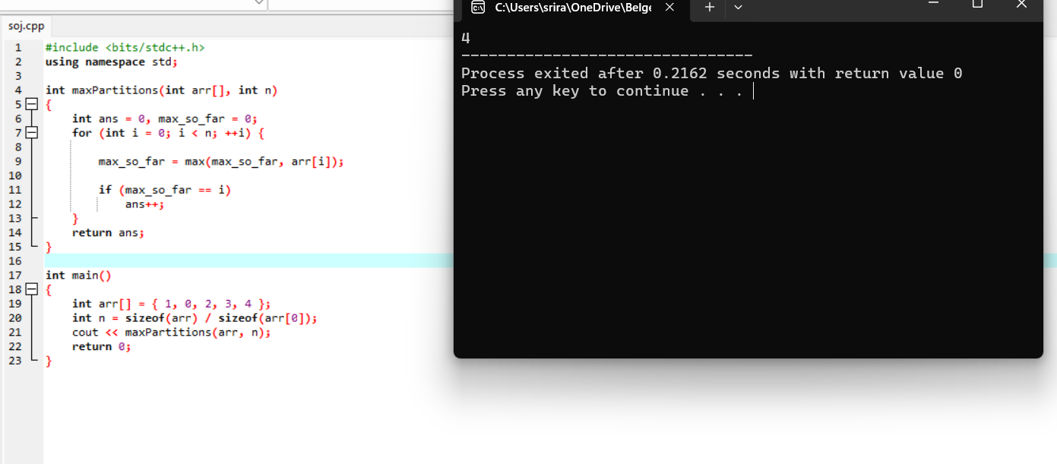

1. **Intersection of Three Sorted Arrays**

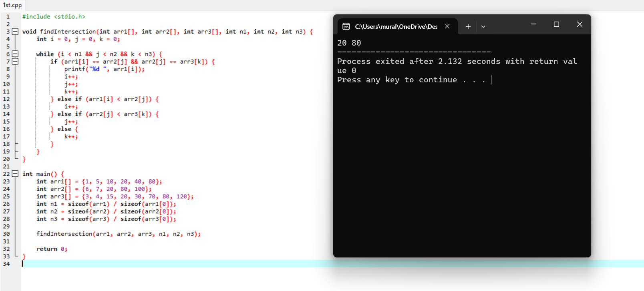

1. **Sort the Matrix Diagonally**

